Equivalent circuit model of transmission lines

Muhammad Hazimi Bin Yusri
Electronics and Computer Science
University of Southampton
Southampton, United Kingdom
mhby1g21@soton.ac.uk

Abstract—This paper analyzes the behavior of coaxial transmission lines for lossless and lossy case in different frequencies at AC and DC voltage step excitation with varied load resistance. The theoretical LC model of the transmission line is derived from the telegrapher’s equations and the lumped element approximation. Resulting waveforms is compared to TL (transmission lines) element provided in MultiSim.

Introduction
The experimental setup consists of a signal generator, an oscilloscope, a coaxial cable equivalent, and a resistive load modeled in MultiSim. The voltage and current waveforms along the transmission line are measured and compared with the theoretical predictions. The results show that the coaxial transmission line exhibits different characteristics depending on the frequency, the load impedance, and the attenuation factor.

Analytical calculation

Characteristic Impedance
First, to model it in MultiSim, the parameters of the line must be known. The coaxial line given have the following parameters given [1]: “The geometry of the coaxial transmission line is schematically shown in Figure 1. The diameter of the inner conductor is d = 0.58 mm, while the inner diameter of the outside conductor is D = 3.7 mm, the relative permittivity of the insulating medium is 𝜀_{𝑟} = 2.2 while the relative permeability of this medium is 𝜇_{𝑟} = 1. For the length of the line assume 100 mm.”
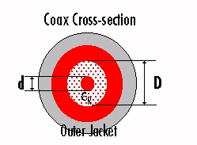
Figure 1.
Thus, according to [2], the capacitance per unit length, C’ (Farads/meter) can be calculated using the following formula (1):
$C^{'}=\frac{C}{l}=\frac{2πε_{0}ε_{r}}{ ln⁡\frac{D}{d}}$ (1)
It is found that C’ is equal to 6.605 x 10⁻¹¹ F/m or 66.05 pF/m. Next, according to [2], the inductance per unit length, L’ (Henry/meter) can be calculated using the following formula (2):
$L^{'}=\frac{L}{l}= \frac{μ_{0}μ_{r}}{2π}ln\frac{D}{d}$ (2)
It is found that L’ is equal to 3.706 x 10⁻⁷ H/m or 0.3706 μH/m. Then, to calculate the characteristic impedance, Z₀ of the line, the following formula (3) from [2] can be used:
$Z_{0}= \sqrt{\frac{L'}{C'}}$ (3)
It is found that Z₀ is equal to 74.91 Ω. This is near to the standard of 75 Ohm impedance.

Time delay and velocity of the transmission line
According to [2], the time delay and velocity of the electromagnetic wave travelling along this coaxial transmission line can be found using following formula:
$v=\frac{1}{\sqrt{L^{'}C^{'}}}$ (4)
$t_{PD}= \sqrt{L^{'}C'}$ (5)
Using (4), velocity of the electromagnetic wave travelling along the transmission line is found to be 2.021 x 10⁸ m/s. Using (5), the propagation time delay is found to be 4.948 x 10⁻⁹ s or 4.948 ns. The velocity ratio against the speed of light in vacuum, c (3 x 10⁸) is then found to be 0.6737. This confirms our calculation for the ratio value should be less than 1 as the speed of electromagnetic waves in any other medium should be slower than in vacuum.

MODELING WITH MULTISIM
Here I will outline the steps I took to model a 32m (as given) coaxial transmission line into MultiSim based on the parameters given and calculated from the previous sections.
Given the frequency bandwidth for the simulation to be of at least 700 MHz, the value of wavelength of the electromagnetic wave can be found using formula (6):
$λ=\frac{v}{f}$ (6)
Where frequency, f is 700 MHz, and v is velocity previously calculated (2.021 x 10⁸ m/s). Wavelength, λ is found to be 0.2887 m. To simulate an electrically long cable, a cascaded element of electrically short cables is added together in series. This must abide the rules such that the length of the short cable is at most one-tenth of λ. Thus, assuming the length of each lumped element to be λ/10, the number of LC element needed per meter is 1/0.02887 = 34.64. To make the simulation more accurate, instead of rounding up thus having 32 blocks of 35 LC elements, a more convoluted approach is taken where 16 blocks will have 35 LC elements and another 16 blocks will have 34 LC elements to average into 34.5 which is nearer to 34.64 .
Thus, value of L and C for each element is calculated by dividing previously calculated value of L’ and C’ by 34.64 which results into 10.7 nH, and 1.907 pF, respectively.

Lossless LC parameters equivalent circuit model
Here is how it looks like for both 34 LC element (Figure 2) and 35 LC element (Figure 3):
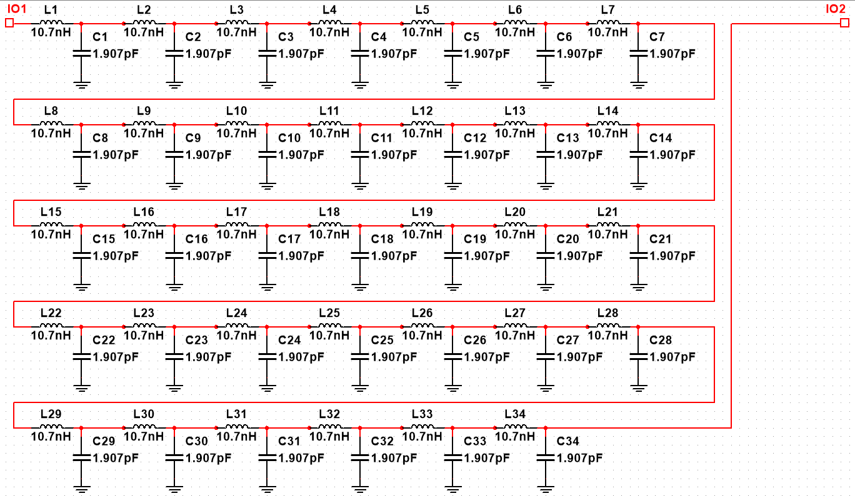
Figure 2.
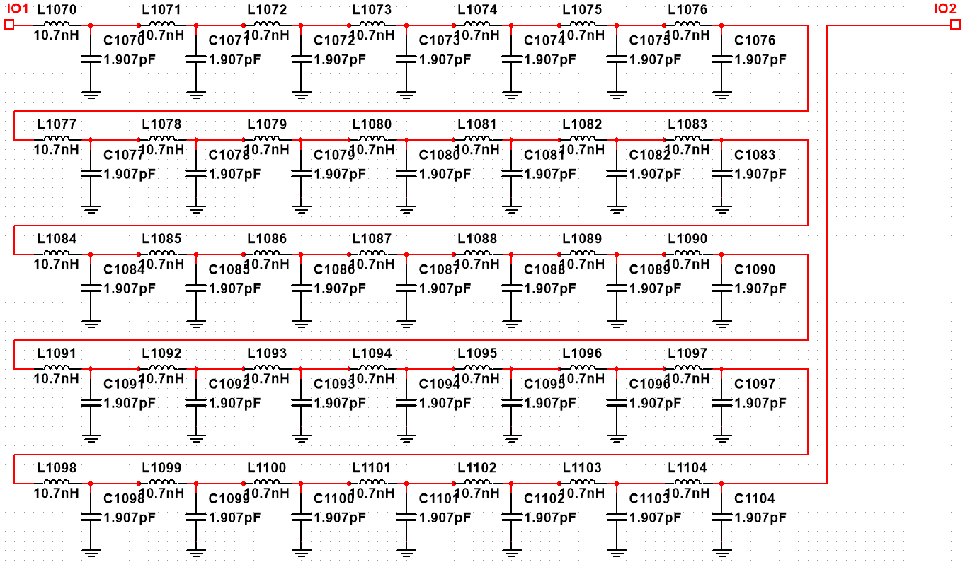
Figure 3.
Another quick check to make sure I had put the correct quantity of LC element is to check the last LC element number, which is 1104, this coincides with total LC element calculation as 34 x 16 + 35 x 16 = 1104. Here is the full circuit diagram:
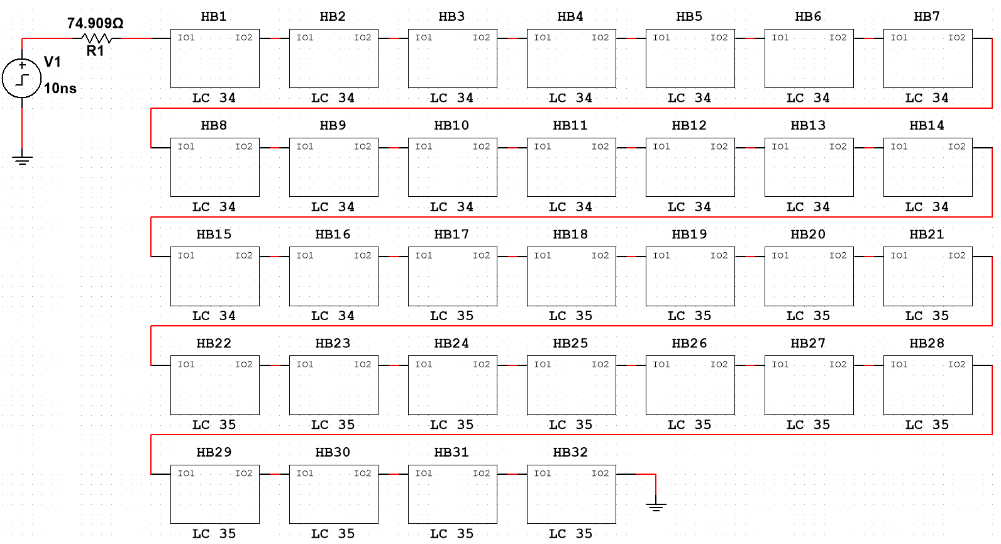
Figure 4. – 32m transmission line made of 32 blocks of 1 m LC elements
A 74.909 Ω resistor which is equal to line characteristic impedance is added next to the step voltage source to account for internal impedance of the source. This is to prevent reflection of signal from load back to source.

MultiSim provided TL element
The provided TL model from MultiSim requires few parameters such as line characteristic impedance, Z₀ and propagation time delay, T_{PD}. Using previous calculation, we found out that Z₀ is 74.909 Ω and T_{PD} = t_{PD} x 32 meter which is 158.3 ns. Figure 5 shows the configuration of said circuit:
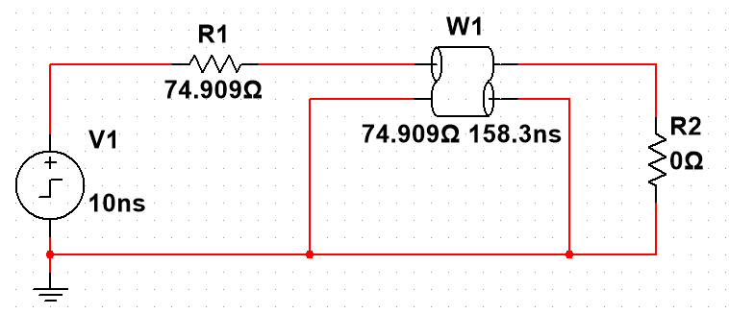
Figure 5.

Lossy Line equivalent circuit model
To model a lossy equivalent circuit, additional parameter are needed which are resistance per length, R’ and conductance per length, G’. These values are calculated using provided excel sheet calculator, in which the latest version is taken from [3] Care must be taken that user defined values are input according to provided excel file in [4] and parameters is set accordingly. The following table shows values for each different frequency to be observed:
Frequency (Hz) | R’(Ω/m) | G’(S/m) | 1/G’(S/m)
1M | 0.202864 | 8.30 x 10⁻⁷ | 1.20 x 10⁶
10M | 0.549241 | 8.30 x 10⁻⁶ | 1.20 x 10⁵
30M | 0.925860 | 2.49 x 10⁻⁵ | 4.02 x 10⁴
Table 1. Obtained result from excel calculator sheet.
Using the value obtained above, R’ and G’ each are inserted to existing models for each 1-meter LC block with R connected in series while G connected in parallel: 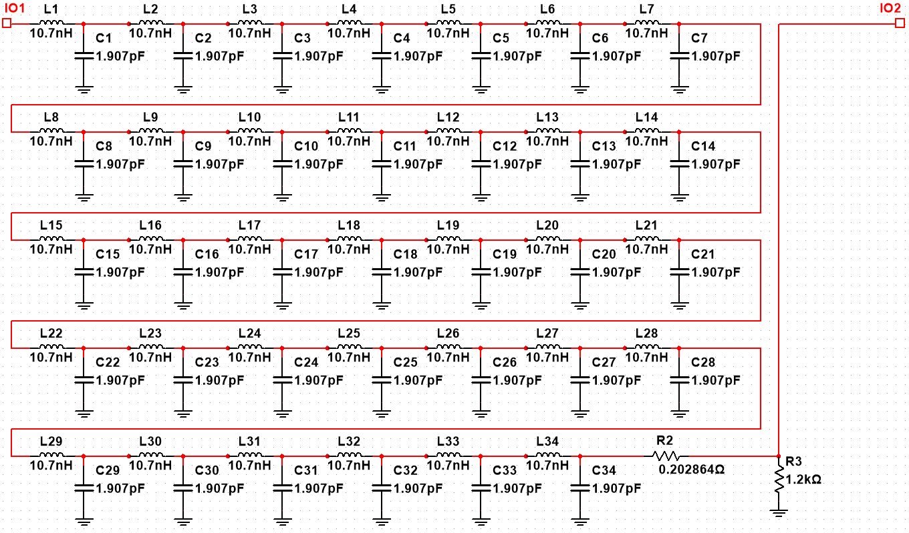
Figure 5. Addition of R2 and R3 at bottom right.

Equations
The equations are an exception to the prescribed
An excellent style manual for science writers is [7].

STUDIES AND ANALYSIS
The lossless circuits modeled in MultiSim will be simulated with DC and AC step excitation. With frequency of 1 MHz, 10 MHz, and 30 MHz for AC. For each step excitation, the voltage and current waveform produced will be compared when the line is terminated with different load value (short circuit, 10 Ω load, 75 Ω load, and open circuit).
The lossy circuit will then be compared with the lossless circuit to study how the change of frequency affect signal loss.

Time domain study for circuit A and B under step voltage excitation.

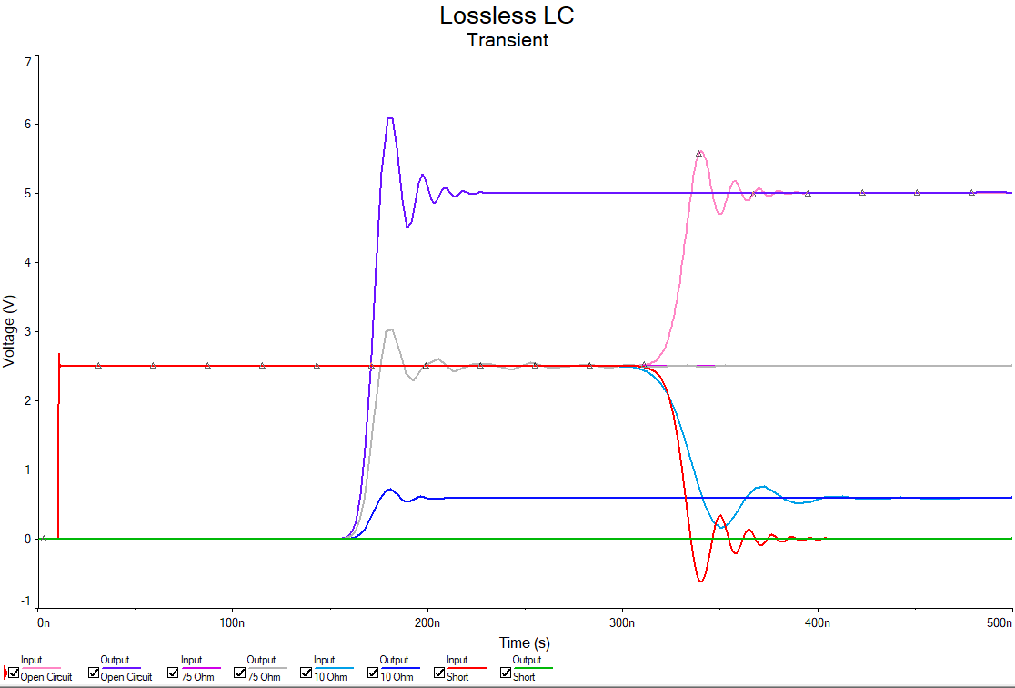
By setting a step voltage source with maximum of 5V and rise time of 0.5 ns, the input and output voltage for both circuit A (lossless LC cascaded elements) and B (MultiSim TL element) can be observed for different load resistance. The figures obtained are as follows:

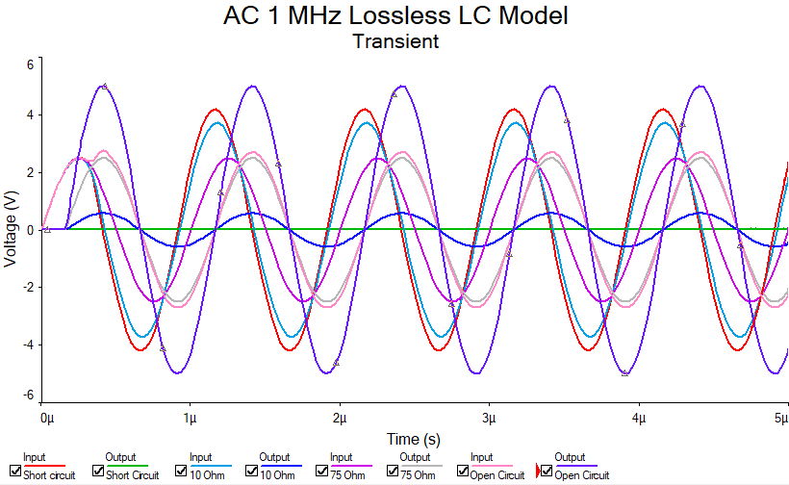
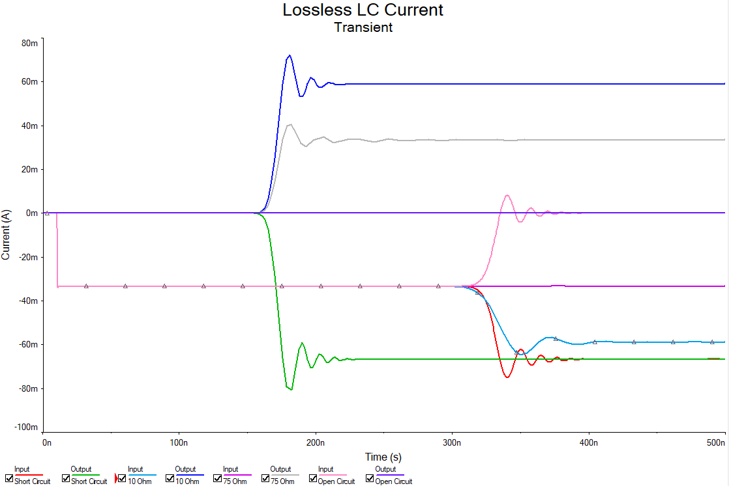
Figure 6. Voltage waveform of lossless LC model
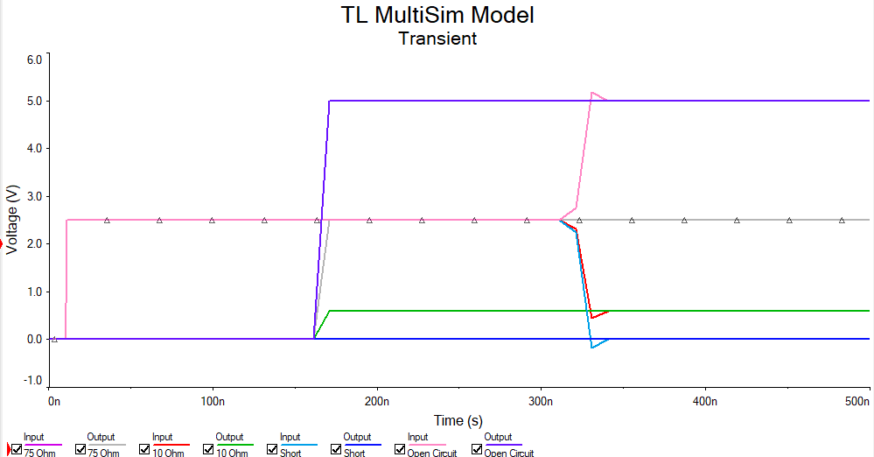
Figure 7. Current waveform of lossless LC model

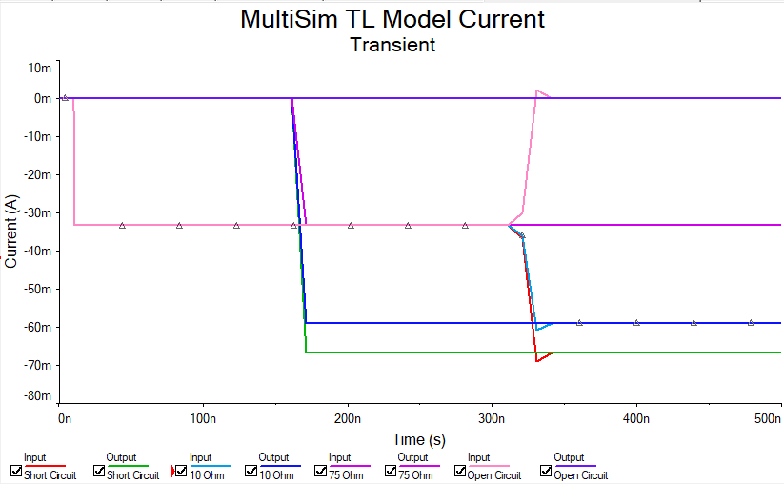
Figure 8. Voltage waveform of MultiSim TL model.

Figure 9. Current waveform of MultiSim TL model.
The presented figures indicate that there is a time delay of approximately 150 ns from input to output in both models, which had been previously calculated analytically. The input voltages are approximately 2.5V which is half of the DC source. The lossless LC model voltages display oscillations or attenuations at the onset of the step input, while the MultiSim TL models show steep lines. Additionally, as the impedance at the load increases, the output voltages increase, with an open circuit exhibiting the maximum voltage of 5V, and a short circuit being lowest at 0V, and this is consistent across both models. This is due to superposition of the reflected and incidence wave from the generator to the load.
Meanwhile, the current waveform exhibits opposing behavior to the voltage graphs, with higher load impedance resulting in lower output current. A short circuit exhibits the highest current output, while an open circuit exhibits no current output.

Time domain study for circuit A and B under AC excitation for different frequencies.
Both the lossless LC and MultiSim TL models were subjected to AC voltage excitation. An AC voltage source with a 5V amplitude and frequencies of 1 MHz, 10 MHz, and 30 MHz were applied, with the same load conditions as previously. The obtained results are presented in the following figures:
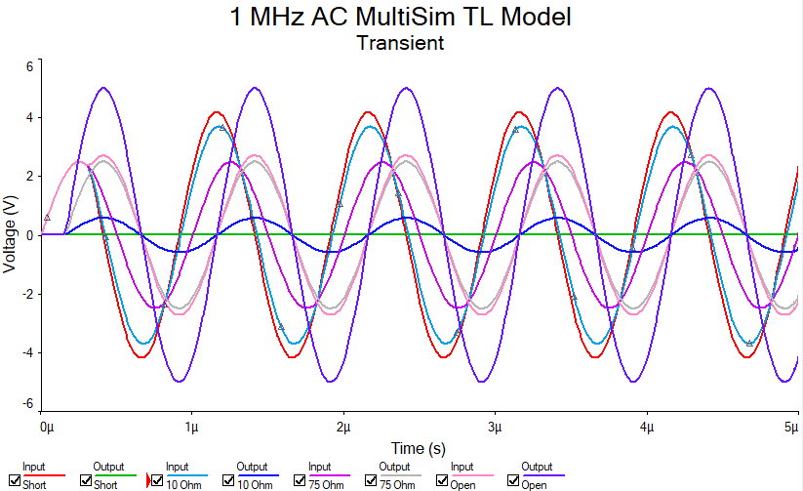
Figure 10. AC 1 MHz Lossless LC model voltage waveform.
Figure 11. AC 1 MHz MultiSim LT model voltage waveform.

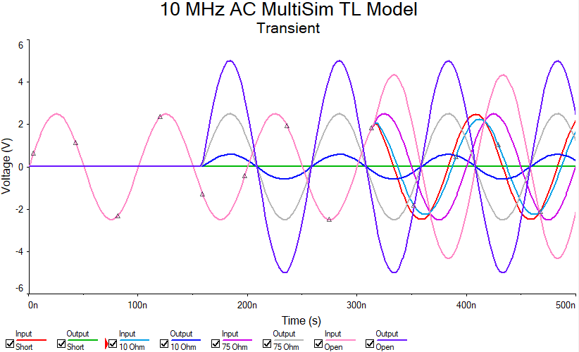
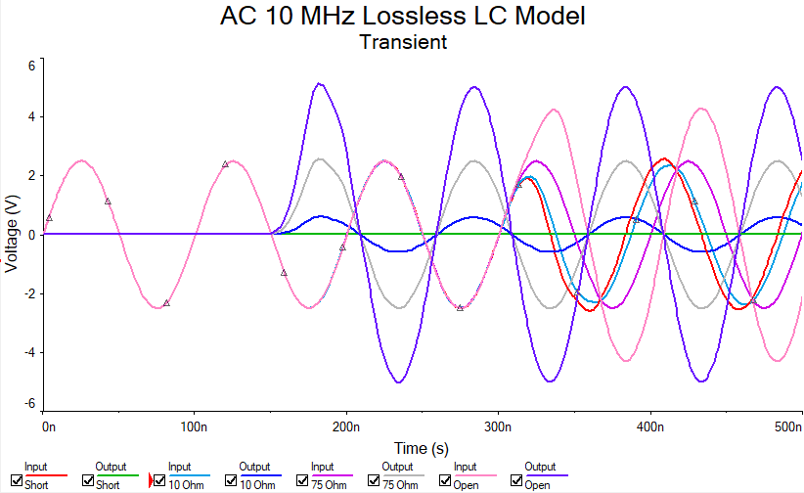
Figure 12. AC 10 MHz Lossless LC model voltage waveform.
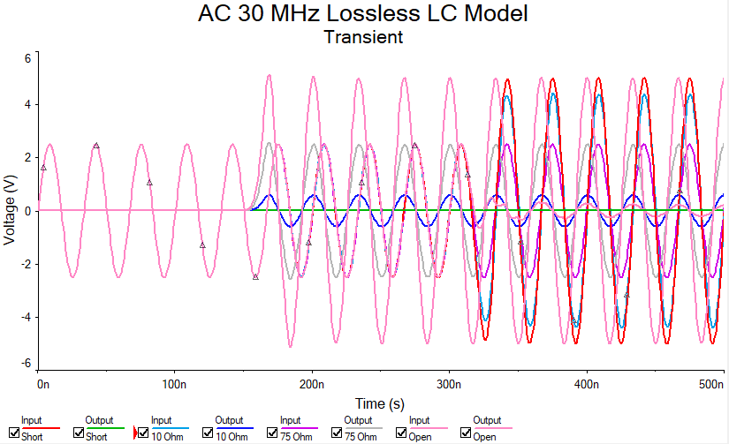
Figure 13. AC 10 MHz MultiSim TL model voltage waveform.
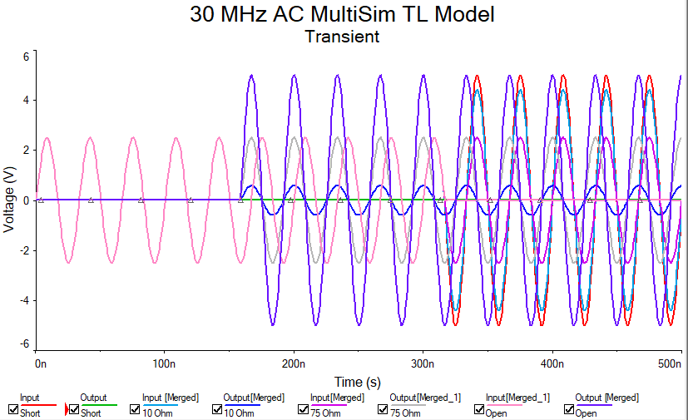
Figure 14. AC 30 MHz Lossless LC model voltage waveform.
Figure 15. AC 30 MHz MultiSim TL model voltage waveform.

After analyzing the figures presented, it can be observed that the output waveform voltages experience a delay due to the time required for the transmission wave to travel through the line. A similar phenomenon is noticeable in the AC circuit, wherein the output voltages vary in magnitude according to the circuit's load impedance. As illustrated in the figures, the voltage output magnitudes increase with higher impedance values, independent of the current frequency. It is worth noting that both models show only slight variations, with only a few instances of reduced values observed in the LC model's simulations.

Zero input impedance based on wavelength and frequency

According to [1]: “As this line is lossless when there is no load (open circuit condition) it should have an infinite input impedance when the line length, l is:
$l= \frac{λ}{2}, λ, \frac{3λ}{2}, 2λ, …$ (7)

and zero input impedance when:
$l= \frac{λ}{4}, \frac{3λ}{2}, \frac{5λ}{2}, …$ (8)
$l= \frac{λ}{4}+ \frac{nλ}{2}, n=0, 1, 2, …$ (9)

When the line is short circuited the complementary behavior is observed. What is the frequency of the voltage source that you need to set-up such that the line has a zero-input impedance when the load is left open?”
Thus, from (6) and (9), we can find out frequency that corresponds to zero input impedance:
n | Line length, l = 32m (m) | Wavelength, λ (m) | Frequency, f (Hz)
0 | λ/4 | 128.00 | 1.58 x 10⁶
1 | 3λ/4 | 42.67 | 4.75 x 10⁶
2 | 5λ/4 | 25.60 | 7.91 x 10⁶
Table 2. Calculation of wavelength and frequency that corresponds to zero input impedance.

Time domain study for lossy line LC model under AC excitation for different frequencies
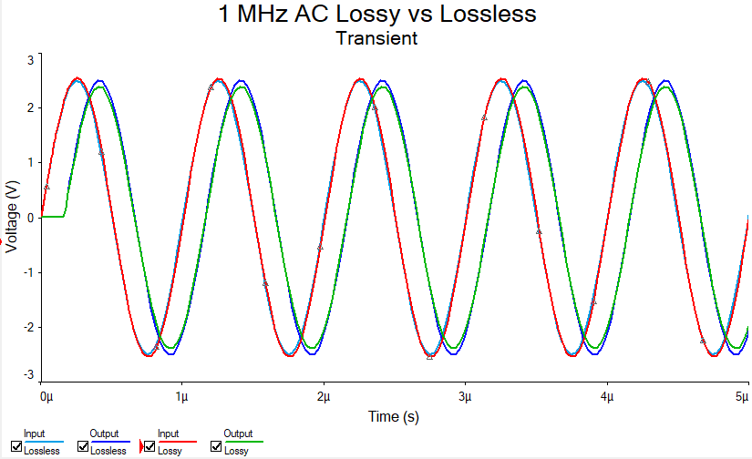
Substituting the value of R’ and G’ for each frequency as calculated in Table 1, the following waveforms are obtained:
Figure 16. 1 MHz AC Lossy and Lossless LC model voltage waveform

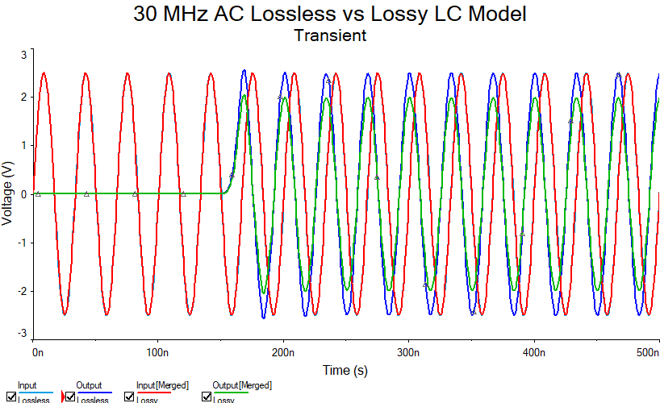
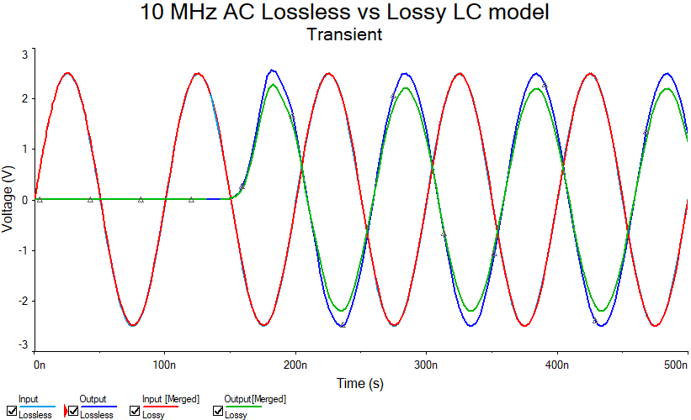
Figure 17. 10 MHz AC Lossless and Lossy LC model voltage waveform.
Figure 18. 30 MHz AC Lossless vs Lossy LC model voltage waveform
Upon constructing the lossy equivalent circuit, a simulation was conducted under a 75ohm load with a step excitation voltage source similar to the lossless section. As depicted in the figures above, minor discrepancies between the lossy and lossless circuits are observed, with the output voltages slightly decreasing due to the inclusion of the G’ and R’ parameters. It is observed that this trend is consistent across all frequencies, with more significant variations observed at higher frequencies.

CONCLUSION
In conclusion, the simulation of lossless and lossy transmission lines is dependent on obtaining the accurate parameters for the transmission lines. It is important to carry out analytical calculations that take into account various factors affecting the voltage magnitudes flowing through the transmission lines. The LC and MultiSim TL models can both be simulated with minimal variation between the two models. However, there are differences in attenuation between the two models that become more pronounced at higher frequencies. Although analytical simulations can be used, 3D simulations for transmission lines may generate more precise real-world results. There is also available the lossy TL component in MultiSim which may have been optimized for such case. This will be proven useful for self-study and learning as the simulation for LC models took a long time on personal computer even with higher-than-average hardware specifications. Overall, the results indicate that a meticulous analysis of the circuit parameters is necessary for simulating transmission lines with the highest level of accuracy.

References
- https://secure.ecs.soton.ac.uk/notes/elec2229/Assignment/ELEC2229_TransmissionLine_Assignment_2023_realisticCoax.pdf (accessed.)
- https://resources.system-analysis.cadence.com/blog/msa2021-transmission-line-propagation-delay-characteristic-impedance-and-dielectric-material (accessed.)
- https://www.microwaves101.com/uploads/Coax-Microwaves101-Rev4.xlsx (accessed.)
- https://secure.ecs.soton.ac.uk/notes/elec2229/Assignment/Coax_rev3.4.xls (accessed.)

